1. Assess deployment

kubectl get po -n udacity

kubectl logs hello-world-dfb5f685c-z2fvt -n udacity

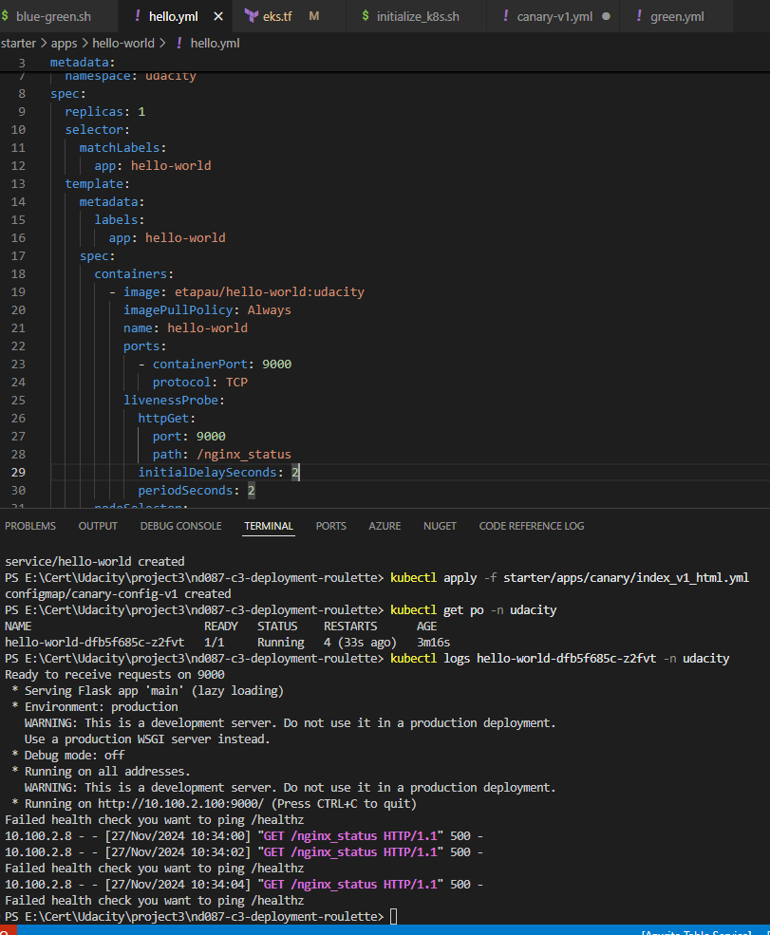

1. Identify issue

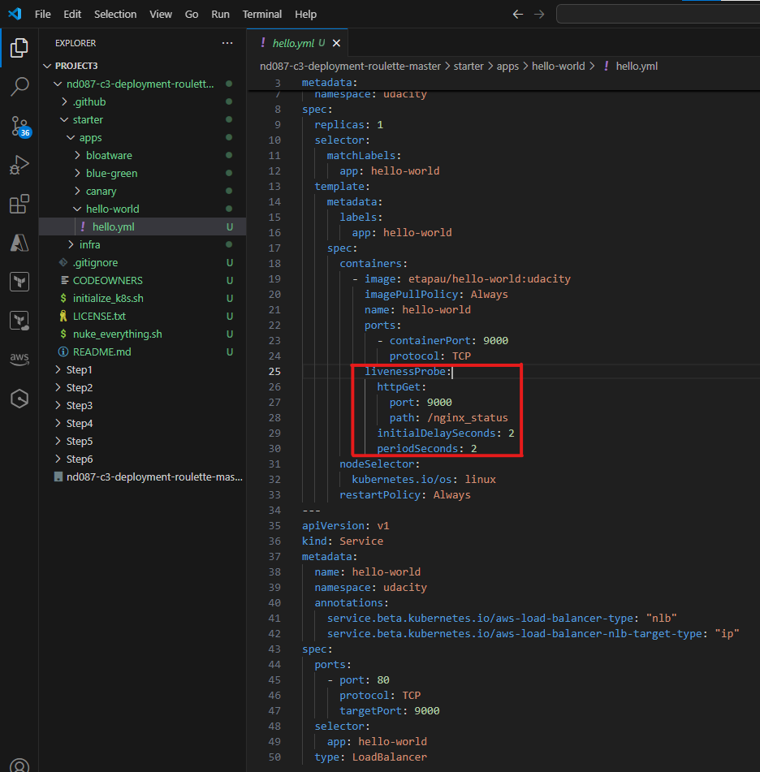

1. Fix issue and result

